Forwarding Table

📤 What Is a Forwarding Table?
# Source: AI Source: Provided by: [Data Path: Persons Table -> ID Column: 1, Name_En Column: Motasem Essam] -> From: [ChatGPT] on [1/16/2026]
A Forwarding Table is a data structure used by network devices like routers and switches to decide how to forward packets or frames to their next destination.
It's like the device’s real-time guidebook for moving data efficiently.

🧠 Simple Definition:
# Source: AI Source: Provided by: [Data Path: Persons Table -> ID Column: 1, Name_En Column: Motasem Essam] -> From: [ChatGPT] on [1/16/2026]
A forwarding table tells a network device which interface (port) to use to send a packet based on its destination address (IP or MAC).

🔀 Used By:
# Source: AI Source: Provided by: [Data Path: Persons Table -> ID Column: 1, Name_En Column: Motasem Essam] -> From: [ChatGPT] on [1/16/2026]
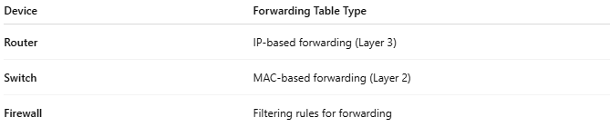

Device | Forwarding Table Type
Router | IP-based forwarding (Layer 3)
Switch | MAC-based forwarding (Layer 2)
Firewall | Filtering rules for forwarding

📦 Forwarding Table vs Routing Table
# Source: AI Source: Provided by: [Data Path: Persons Table -> ID Column: 1, Name_En Column: Motasem Essam] -> From: [ChatGPT] on [1/16/2026]
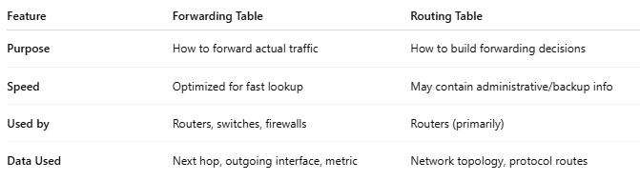

Feature | Forwarding Table | Routing Table
Purpose | How to forward actual traffic | How to build forwarding decisions
Speed | Optimized for fast lookup | May contain administrative/backup info
Used by | Routers, switches, firewalls | Routers (primarily)
Data Used | Next hop, outgoing interface, metric | Network topology, protocol routes
🔧 Often, a forwarding table is built from the routing table (especially in routers).

📋 Examples

▶ For a Switch (Layer 2 Forwarding Table / MAC Table):
# Source: AI Source: Provided by: [Data Path: Persons Table -> ID Column: 1, Name_En Column: Motasem Essam] -> From: [ChatGPT] on [1/16/2026]
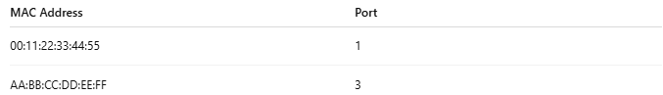

MAC Address | Port
00:11:22:33:44:55 | 1
AA:BB:CC:DD:EE:FF | 3
📌 If a frame arrives with destination MAC AA:BB:CC:DD:EE:FF, the switch forwards it out port 3.

▶ For a Router (Layer 3 Forwarding Table):
# Source: AI Source: Provided by: [Data Path: Persons Table -> ID Column: 1, Name_En Column: Motasem Essam] -> From: [ChatGPT] on [1/16/2026]
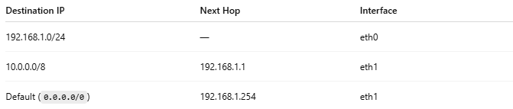

Destination IP | Next Hop | Interface
192.168.1.0/24 | — | eth0
10.0.0.0/8 | 192.168.1.1 | eth1
Default (0.0.0.0/0) | 192.168.1.254 | eth1
📌 If a packet for 10.1.2.3 arrives, it’s forwarded to 192.168.1.1 via eth1.

🛠️ How Forwarding Works (Simplified):
# Source: AI Source: Provided by: [Data Path: Persons Table -> ID Column: 1, Name_En Column: Motasem Essam] -> From: [ChatGPT] on [1/16/2026]
- Packet/frame arrives at the device.
- Device extracts the destination address.
- Looks up that address in the forwarding table.
- Forwards the data out the specified interface or port.

✅ Summary
# Source: AI Source: Provided by: [Data Path: Persons Table -> ID Column: 1, Name_En Column: Motasem Essam] -> From: [ChatGPT] on [1/16/2026]
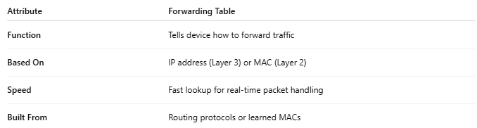

Attribute | Forwarding Table
Function | Tells device how to forward traffic
Based On | IP address (Layer 3) or MAC (Layer 2)
Speed | Fast lookup for real-time packet handling
Built From | Routing protocols or learned MACs

